RDAP Outline Design
Table of contents
1 Overview 2
1.1 Architecture 2
1.1.1 Overview of Modules 2
1.1.2 Related Outer Objects 3
1.1.3 Query Process 3
2 RDAP Server Modules 4
2.1 Presentation layer 4
2.1.1 Port43 Proxy 4
2.1.2 Request Filter 4
2.1.3 REST API 5
2.2 Business Layer 7
2.2.1 RDAP Core Service 7
2.2.1.1 Query 7
2.2.1.2 Search 7
2.2.1.3 Redirect 8
2.2.1.4 Object Models 8
2.2.1.5 Util 9
2.2.2 Auth 9
2.2.2.1 Authentication 9
2.2.2.2 Authorization 10
2.2.2.2.1 Access Control List 10
2.2.2.2.2 Access Controller 10
2.2.3 Policy Control 11
2.2.4 IANASync 12
2.3 Data Access Layer 12
2.3.1 Data Access 12
2.4 Related Outer Object 13
2.4.1 Data Source 13
2.4.2 Client 13
2.4.3 IANA 14
3 Physical Deployment 14
4 Extension 14
4.1 Custom column extension 14
4.2 Other extension 15
5 References 15

Overview
RDAP: implementation of Registration Data Access Protocol.

Architecture
Architecture of RDAP is shown as Figure 1.1-1.
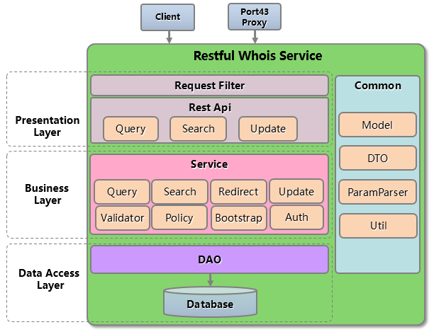
Figure 1.1-1 RDAP Architecture

Overview of Modules
- Presentation Layer
  - Port43 Proxy: proxy for port43-whois-client conforms to [RFC3912].
  - Request Filter: limit rate, handle requests with non-HTTP GET method.
  - Rest API: query, search and update API.
- Business Layer
  - RDAP Service
    - Query: query registration data by exactly matching.
    - Search: search registration data.
    - Redirect: redirect service for non-authoritative objects of this registry, see [RFC 7480].
    - Update: update API, used to update RDAP data.
    - Auth: authentication and authorization.
    - Policy Control: used to hide some columns of objects according to registry’s policy.
    - Bootstrap: synchronize ‘Redirect Table’ from IANA’s ‘RDAP Registry’, ‘Redirect Table’ is used in Redirect module (see section 2.2.3).
    - Validator: validate query parameters.
  - RDAP Service
    - Model: object models corresponding to Object Class in RDAP JSON response, see [RFC 7483].
    - DTO: data transfer object, used for API.
    - ParamParser: parse query parameters.
    - Util: validate query parameters, and convert data format.
- Data Access Layer
  - DAO: access data from data source.
  - Database: Mysql database.

Related Outer Objects
- Client: the client of the RDAP Server.
- IANA RDAP Registry: ‘Redirect Table’ used for Redirect service is synchronized from RDAP Registry in IANA, see [RFC 7480].

Query Process
For illustrative purposes, a domain query process by a logined client is shown as following Figure 1.1.3-1.
- The client sends a domain query request ‘/domain/cnnic.cn’ to RDAP Server.
- Request Filter check whether query frequency of this client exceeds the system limit.
- Call Rest API.
- Rest API parses the request URI and obtains query type - ‘domain’, and call Query module.
- Query module checks the validity of request parameter.
- If query parameter is valid, then Query module calls Data Access module.
- Query module calls Policy Controller to remove some columns from the result according to policy. See section 2.2.3.
- Query module calls Auth module, Auth module removes columns which is not accessible to this client. See section 2.2.2.2.
- Query module formats result data to JSON by calling Util module.
- Rest API writes JSON response to client
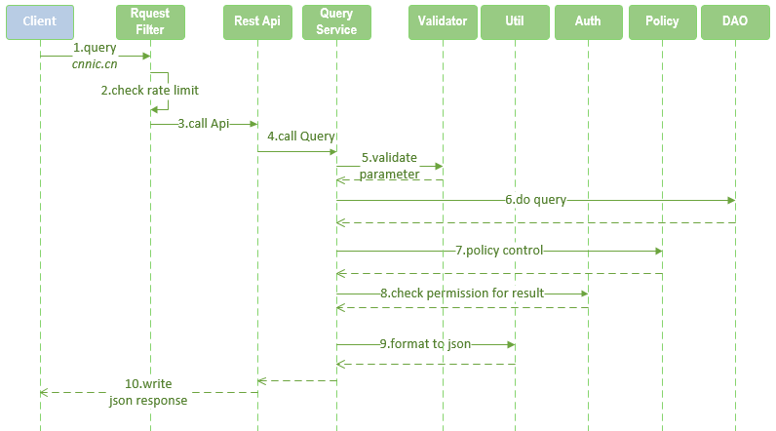
Figure 1.1.3-1 Domain query process

RDAP Server Modules

Presentation layer
Presentation Layer is designed to display the user interface and manage user interaction.

Port43 Proxy
Port43 Proxy is a user interface which is able to accept client queries via port 43, conforming to [RFC3912].
Port43 Proxy transmits port43 queries to HTTP queries that can be accepted by Request Filter (see section 2.1.2).
Class Diagram: https://github.com/cnnic/rdap/wiki/proxy43-class--diagram.

Request Filter
Request Filter is designed to manage interaction with clients.
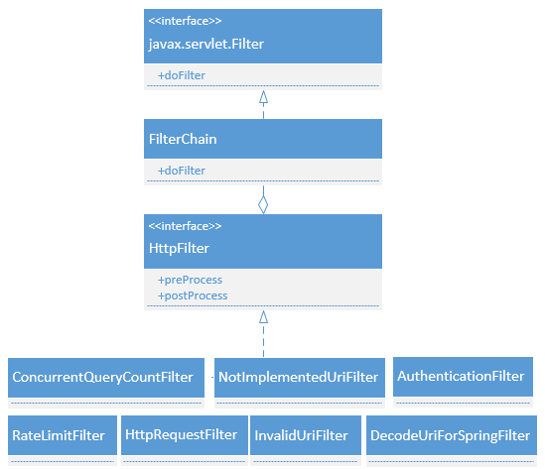
Figure 2.1.2-1 Request Filter class
Description of classes:
- Javax.servlet.Filter: servlet filter interface. Request Filter module depends on servlet filter.
- FilterChain: contains all filters in RDAP Server, and invokes them to filter request.
- HttpFilter: filter interface for all HTTP filters in RDAP Server. It has two methods to be implemented:
  - preProcess: this is called before process service.
  - postProcess: this is called after process service.
- HttpFilter implementation
  - RateLimitFilter: prevents highly frequent queries, it returns 429 error to client if query interval is shorter than the configured interval.
  - ConcurrentQueryCountFilter：controls the concurrent query count.
  - HttpRequestFilter: handles requests with non-HTTP GET method, and it will return error to client.
  - AuthenticationFilter: authenticates, and gets authentication information from client.
  - InvalidUriFilter: handles invalid URI.
  - DecodeUriForSpringFilter：decodes URI for spring MVC.
  - NotImplementedUriFilter：handles the not-implemented URI.

REST API
There are 2 types of Rest API:
- Query API and Search API
- Update API
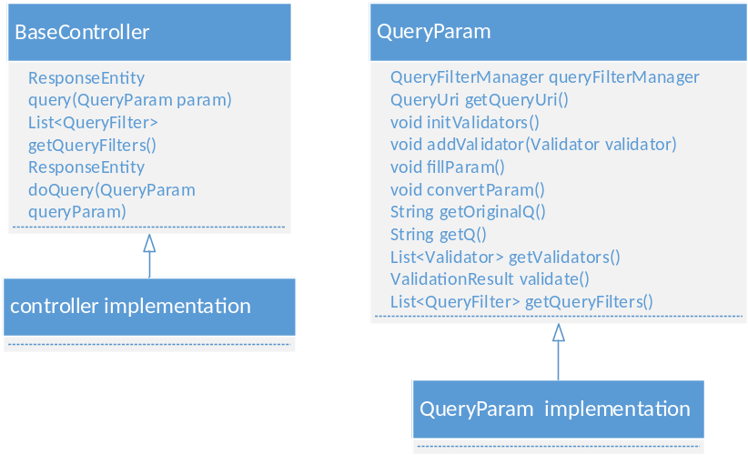
Figure 2.1.3-1 Query and Search API class
Description of class:
- BaseController: base controller for query/search service. It has a template method for querying, and the method ‘doQuery’ need to be implemented by subclass.
- QueryParam: base query parameter bean.
Query process:
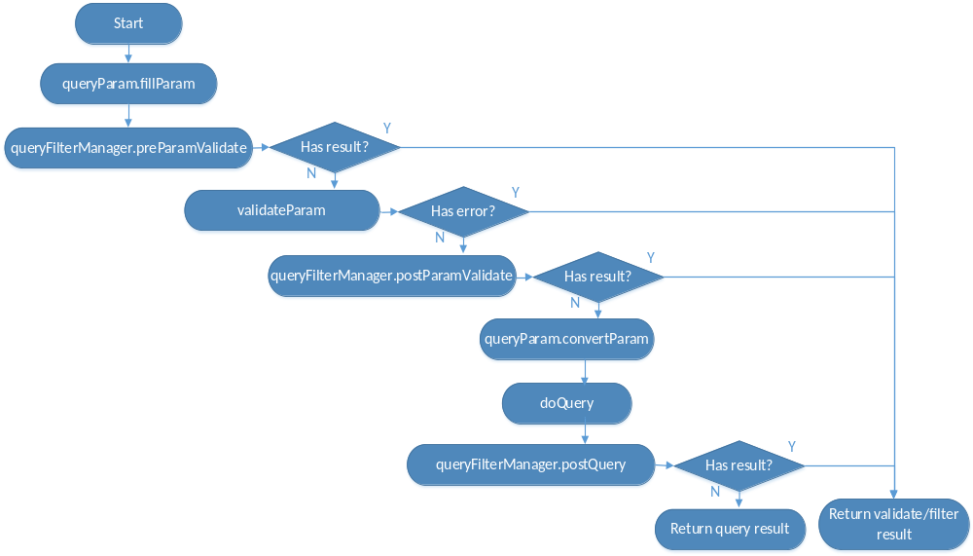
Figure 2.1.3-2 Query process

Business Layer

RDAP Core Service
RDAP Core Service is the core of the RDAP Server and contains Query, Search, Redirect and Object Models.

Query
Query service is designed to lookup registration objects. Class diagram is shown as following figure.
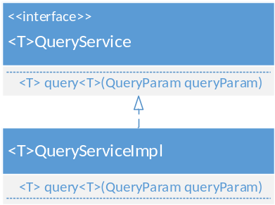
Figure 2.2.1-1 Query Service class
Every model type has its query service interface and implementation, called <T>QueryService and <T>QueryServiceImpl, ‘T’ is model type name.

Search
Search service class diagram is shown as following figure.
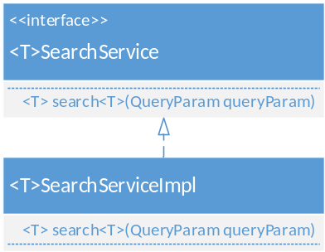
Figure 2.2.1-2 Search service class
Every model type has its search service interface and implementation, called <T>SearchService and <T>SearchServiceImpl, ‘T’ is model type name .

The process for different search type is different and handled by search strategy:

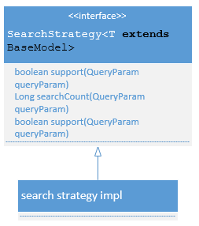
Figure 2.2.1-3 Search strategy class

Redirect
Redirect module is designed to query authoritative RDAP server information for non-authoritative query of this RDAP Server. This is done by querying a ‘Redirect Table’, which is synchronized from IANA RDAP Registry periodically, see [RFC 7480].
Redirecting is done by a implementation of HttpFilter:
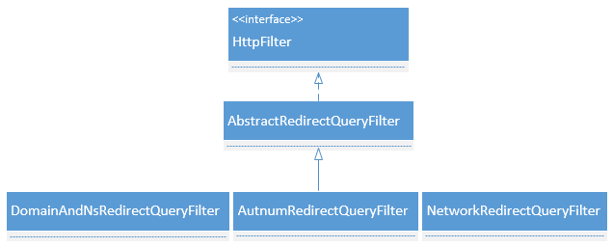
Figure 2.2.1.3-1 Search service class

Object Models
Object Model class is shown as following figure. Some joined-objects are not included.

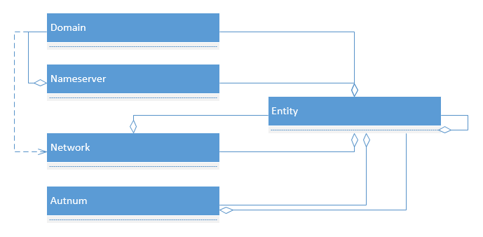
Figure 2.2.1-4 Object Models class

Util
Util module contains validating and data converting utility.
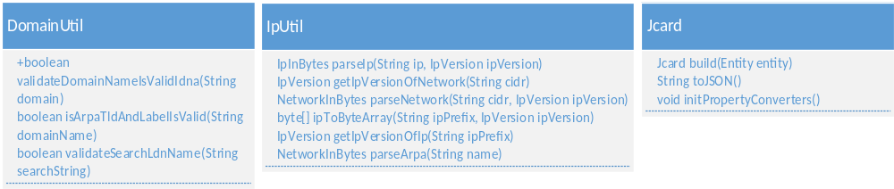
Figure 2.2.1-5 Util class
- DomainUtil: validate a-label/u-label domains according to [RFC1035] and [RFC5891].
- IpUtil: validate ipv4/ipv6/arpa; convert ip/arpa from/to byte value.
- Jcard: format entity information to Jcard (see [RFC 7483]) format.

Auth
Auth module is used for authentication and authorization.

Authentication
Authentication module has a default implementation by using HTTP Basic + TLS, see [RFC 7481].
It is done by AuthenticationFilter, a implementation of HttpFilter.

Authorization
Authorization module is designed to control access to resources in RDAP Server, just as shown in figure 2.2.2-2.
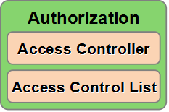
Figure 2.2.2-2 Authorization module

Access Control List
RDAP Server uses Access Control List (ACL) for authorization, ACL is a permission control model, see [RFC4949].
ACL model is shown as following figure.
Figure 2.2.2-3 ACL Model
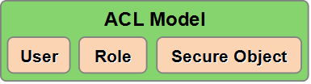
- User: authenticated user.
- Role: role of user.
- Secure Object: resource to be protected. There are two kinds of Secure Object:
- Registration Object: per registration object.
- Uri: protected Uri of RDAP Server, such as ‘/domains’, ‘/nameservers’.

Access Controller
Access Controller is a module to Control access to Secure Object when query or search, non-authorized access will be forbidden.
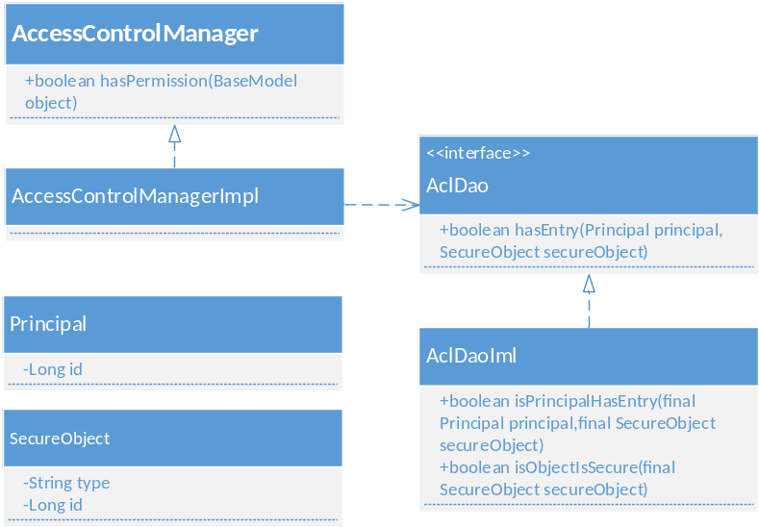
Figure 2.2.2-4 Access Controller class
Class description:
- Principal: client's identity.
- SecureObject: object that needs access control.
- AccessControlManager: access control interface.
- AccessControlManagerImpl: default implementation of AccessControlManager. All Registration object is readable (or accessible) for all users by default. An authorization entry [user-role-secure Object] will be added when permission control is needed. users who have no entry for this secure object will be forbidden to access this object.
- AclDao: used to load ACL entry.
- AclDaoImpl: default implementation of AclDao, by loading ACL entry from Database.

Policy Control
Policy Control is used to hide some columns of objects according to registry’s policy.
It is done by the implementation of HttpFilter.
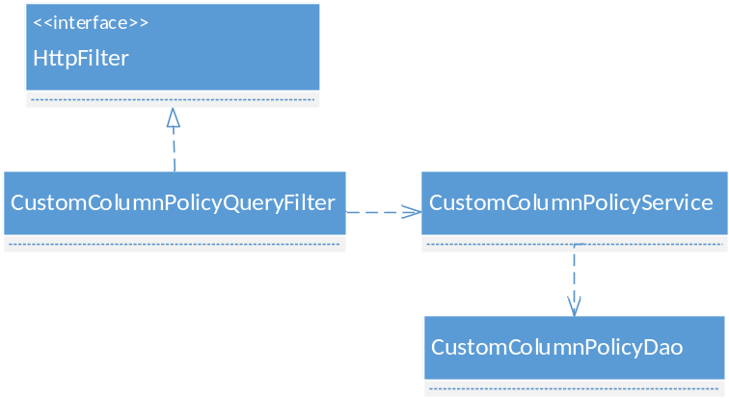
Figure 2.2.3-1 Policy Control class

IANASync
The Redirect module depends on a ‘Redirect table’, IANASync module is designed to synchronize this Redirect table from IANA periodically.

Data Access Layer
Data Access Layer is designed to access RDAP data from data source.

Data Access
Data Access is aimed at making it easy to work with different data sources.
Data Access module has a default implementation for MYSQL database accessing, this implementation can be replaced by writing custom Data Access implementation and providing database SQL dialect for specified database (see section 4.1).

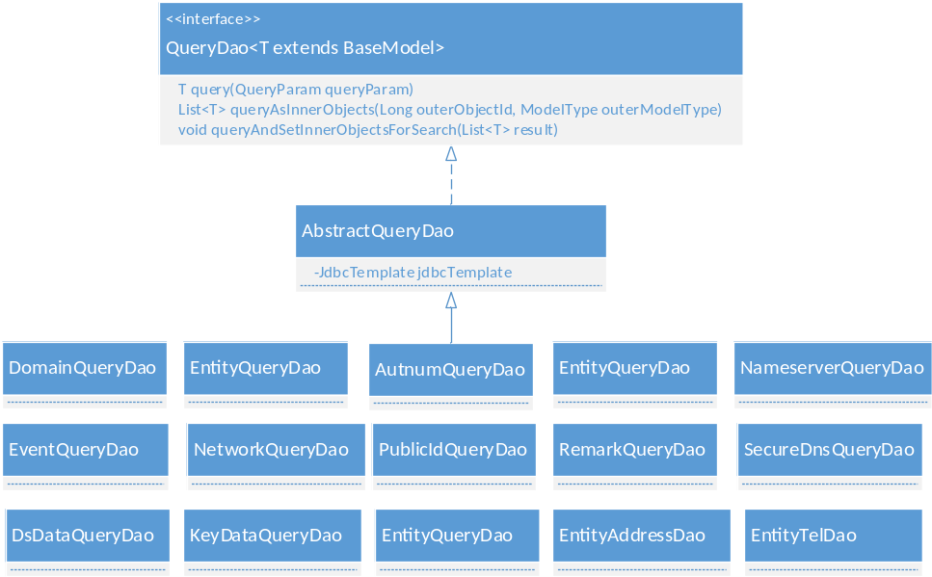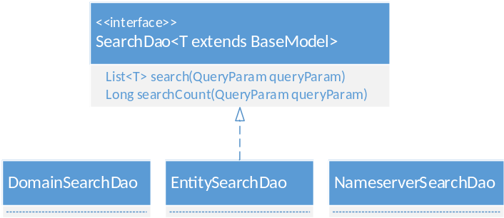
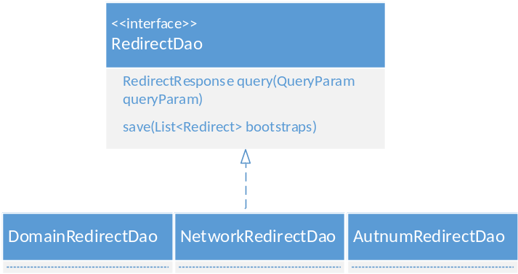
Figure 2.3.1-1 Data Access class
Class description:
- QueryDao: query DAO interface.
- SearchDao: search DAO interface
- RedirectDao: redirect DAO interface.

Related Outer Object
Related outer object to RDAP Server.

Data Source
Data source of RDAP Server, with the default database of MYSQL, can be replaced by specified data source if Data Access implementation is replaced by corresponding data source (see section 4.1).

Client
Send query/search requests to RDAP Server, and get corresponding responses.
- Http Client: Client that can direct access to RDAP Server using HTTP1.1, eg: using Linux command ‘wget’ or ‘curl’ to send requests to RDAP Server.
- Port43 Client: Client that can access WHOIS service via port 43 conforming to [RFC3912].

IANA
IANA maintains RDAP Registry, see [RFC 7480], which is used by RDAP Server’s ‘Redirect Table’ for redirect service.

Physical Deployment

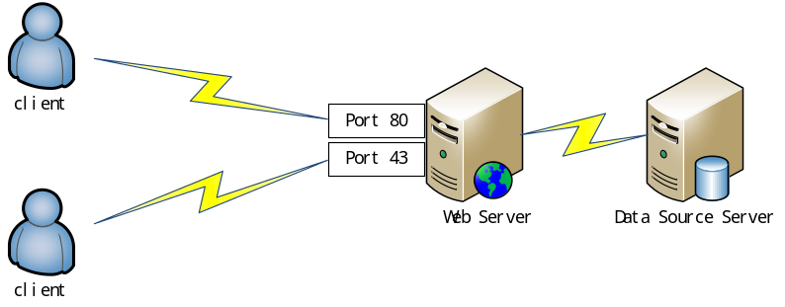
Figure 3-1 Physical Deployment
Web Server: Web Container (such as tomcat) with RDAP Server deployment on it. Registry can deploy more than one Web Server to improve performance. (TBD)
Data Source Server: Data Source server, such as MYSQL Server. Registry can deploy more than one Data Source Servers to improve performance. (TBD)

Extension

Custom column extension
Query object for domain/nameserver/entity/as number/ip can has dynamic columns.
- Database support: these tables has an extension column ‘CUSTOM_PROPERTIES’, which is in JSON format and is used to store dynamic column key-value.
- Code support: The base model of all object - ‘BaseModel’ has a ‘map’ type property called ‘customProperties’, which is used to maintain dynamic column key-value.

Other extension
Please ref Customize and Develop.

References
[RFC 7483] JSON Responses for the Registration Data Access Protocol (RDAP)
[RFC 7482] Registration Data Access Protocol (RDAP) Query Format
[RFC 7480] HTTP Usage in the Registration Data Access Protocol (RDAP)
[RFC 7481] Security Services for the Registration Data Access Protocol (RDAP)
[RFC3912] WHOIS Protocol Specification
[RFC1035] Domain names - implementation and specification
[RFC5891] Internationalized Domain Names in Applications (IDNA)
[RFC4949] Internet Security Glossary, Version 2

